

**DR. B. C. ROY ENGINEERING COLLEGE,**

**DEPARTMENT OF COMPUTER SCIENCE &ENGINEERING**

**DURGAPUR-713206**

**A PROJECT REPORT ON**

**“DESKTOP ASSISTANT USING PYTHON”**

SUBMITTED BY:

SAMADRITA SINHA(12000122064)

AKASH GHOSH(12000122041)

SOUMAK HALDER(12000122039)

SOURIK NANDI(12000122056)

UNDER GUIDENCE OF:

**DR.SUMANA KUNDU**

(ASSOCIATE PROFESSOR)

**&**

**PROF.BISWAJIT SAHA**

(ASST.PROFESSOR)

DEPARTMENT OF CSE

**DECLARATION**

I hereby declare that the Project work entitled “**DESKTOP ASSISTANT USING PYTHON**”submitted to the DR. B. C. Roy Engineering College,is a record of an original work done by us under the guidance of **DR. SUMANA KUNDU** and this project work is submitted in the partial fulfilment of the requirements for the award of the degree of B.TECH in Computer Science & Engineering.The results embodied in this thesis have not been submitted to any other university or Institute for the award of any degree or diploma.

**DATE:**

**PLACE: SIGNATURE OF THE CANDIDATE**

### ACKNOWLEDGEMENT

I would like to express my sincere and a deep sense of gratitude to my Project Guide Dr.Sumana Kundufor her valuable guidance, suggestions and constant encouragement paved way for the successful completion of our project work.

I wish to express my thanks to the management and all Teaching and Non-teaching staff members of the Department of Computer Science and Engineeringwho were helpful in many ways for the completion of the project.

Also,I thank my parents and friends for supporting me in the completion of this project within the limited time frame.

### ABSTRACT

A Desktop Assistant is one of the hot topics in the current world that are programs that listens to human’s verbal command and respond to them which makes it a human computer/device interaction. In the current days, a voice assistant is everywhere which is a lot useful in these busy days. Nowadays, almost everyone in the current world is using voice assistant because it’s everywhere starting from Google smartphone assistant which even 5 years old kids will know how to use because of the current world pandemic which makes them use smartphones till Amazon's Alexa which will be very useful to do works starting from entertaining the users till turning on and off the household products (Internet of Things). One of the greatest features is that it will be very useful to even physically challenged people, for example, people who aren't able to walk use the Internet of Things (IoT) feature to operate the household products and maintain them. So, we tend to develop a voice assistant which will be very useful to the users same as the other voice assistants which are currently in the world.

### TABLE OF CONTENTS

### INTRODUCTION……………………………………………..1

### LITERATURE SERVEY………………………………………2

### METHODOLOGY……………………………………………..3

### REQUIREMENT ANALYSIS(SRS)………………………….4-6

### DFD……………………………………………………………7-8

### ER DIAGRAM…………………………………………………9

THEORY OF COMPUTATION………………………………..10-14

### RESULTS & ANALYSIS……………………………………….15

### CONCLUSION………………………………………………….16

### FUTURE SCOPE………………………………………………..17

### REFERENCES …………………………………………………..18

### INTRODUCTION

The very first voice activated product was released in 1922 as Radio Rex. This toy was very simple, wherein a toy dog would stay inside a dog house until the user exclaimed its name, “Rex” at which point it would jump out of the house. This was all done by an electromagnet tuned to the frequency similar to the vowel found in the word Rex, and predated modern computers by over 20 years.

In the 21st century, human interaction is being replaced by automation very quickly. One of the main reasons for this change is performance. There’s a drastic change in technology rather than advancement. In today’s world, we train our machines to do their tasks by themselves or to think like humans using technologies like Machine Learning, Neural Networks, etc. Now in the current era, we can talk to our machines with the help of virtual assistants.

Virtual assistants are software programs that help you ease your day-to-day tasks, such as showing weather reports, giving daily news, searching the internet etc. They can take commands by voice. Voice-based intelligent assistants need an invoking word or wake word to activate the listener, followed by the command. We have so many virtual assistants, such as Apple’s Siri, Amazon’s Alexa and Microsoft’s Cortana and Amazon's Alexa and this has been an inspiration for us to do this as a project. This system is designed to be used efficiently on desktops. Voice assistants are programs on digital devices that listen and respond to verbal commands. A user can say, “What's the weather?” and the voice assistant will answer with the weather report for that day and location.

**1**

**LITERATURE SURVEY**

This field of virtual assistants having speech recognition has seen some major advancements or innovations. This is mainly because of its demand in devices like smartwatches or fitness bands, speakers, Bluetooth earphones, mobile phones, laptop or desktop, television, etc. Almost all the digital devices which are coming nowadays are coming with voice assistants which help to control the device with speech recognition only. A new set of techniques is being developed constantly to improve the performance of voice automated search. As the amount of data is increasing exponentially now known as Big Data the best way to improve the results of virtual assistants is to incorporate our assistants with machine learning and train our devices according to their uses. Other major techniques that are equally important are Artificial Intelligence, Internet of Things, Big Data access and management, etc. With the use of voice assistants, we can automate the task easily, just give the input to the machine in the speech form and all the tasks will be done by it from converting your speech into text form to taking out keywords from that text and execute the query to give results to the user. Machine Learning is just a subset of Artificial Intelligence. This has been one of the most helpful advancements in technology. Before AI we were the ones who were upgrading technology to do a task but now the machine is itself able to counter new tasks and solve it without need to involve the humans to evolve it.This has been helpful in day-to-day lifestyle. From mobile phones to personal desktops to mechanical industries these assistants are in very much demand for automating tasks and increasing efficiency.

* **Nivedita Singh** (2021) et al. proposed a voice assistant using python speech to text (STT) module and had performed some api calls and system calls which has led to developing a voice assistant using python which allows the user to run any type of command through voice without interaction of keyboard. This can also run on hybrid platforms. Therefore, this paper lacks in some parts like the system calls that aren’t much supported.
* **Abeed Sayyed** (2021) et al. presented a paper on Desktop Assistant AI using python with IOT features and also used Artificial Intelligence (AI) features along with a SQLite DB with the use of Python. This Project has a Database connection and a query framework but lacks API call and System calls features.
* **P.Krishnaraj** (2021) et al. presented a project on Portable Voice Recognition with GUI
* Automation, This system uses Google’s online speech recognition system for converting speech input to text along with Python. Therefore, this project has a GUI and is also has a portable framework. Accuracy of this text to speech (TTS) engine is comparatively less and also lacks IoT.
* **Rajdip Paul** (2021) et al. presented a project named A Novel Python-based Voice Assistance System for reducing the Hardware Dependency of Modern Age Physical Servers. This Author has proposed assistant project with python as a backend supporting system calls, api calls and various features. This Project is quite well responsive with api calls, also needs improvement in understanding and reliability.
* **V. Geetha** (2021) et al. presented a project named The Voice Enabled Personal Assistant for Pc using Python. This Author has proposed assistant project with python as a backend and features like turning our PC off, or restarting it, or reciting some latest news, are just one voice command away. Also, this project has well supported library not every API will have the capability to convert the raw JSON data into text. And there is a delay in processing request calls.

**2**

**METHODOLOGY**

#### PROPOSED SYSTEM

We are proposing a system in an efficient way of implementing a Personal voice assistant, Speech Recognition library has many in-built functions, that will let the assistant understand the command given by user and the response will be sent back to user in voice, with Text to Speech functions. When assistant captures the voice command given by user, the under lying algorithms will convert the voice into text. And according to the keywords present in the text (command given by user), respective action will be performed by the assistant. This is made possible with the functions present in different libraries. Also, the assistant was able to achieve all the functionalities with help of some API’s. We had used these APIs for functionalities like performing calculations, extracting news from web sources, and for telling the weather. We will be sending a request, and through the API, we’re getting the respective output. API’s like WOLFRAMALPHA, are very helpful in performing things like calculations, making small web searches. And for getting the data from web. In this way, we are able to extract news from the web sources, and send them as input to a function for further purposes. Also, we have libraries like Random and many other libraries, each corresponding to a different technology. We used the library OS to implement Operating System related functionalities like Shutting down a system, or restarting a system.

**3**

**REQUIREMENT ANALYSIS(SRS)**

**Software Requirements:**

* Python 3.5 & Above

* Windows 7 And Above

**Hardware Requirements:**

* Processor: Intel Core i3 & above

* RAM: 4GB

* OS: Windows

* Microphone

**Libraries:**

* **Pyttsx3-** It is a text to speech conversion library in python which is used to convert the text given in the parenthesis to speech. It is compatible with python 2 and 3. An application invokes the pyttsx3.init() factory function to get a reference to a pyttsx3. it is a very easy to use tool which converts the entered text into speech. The pyttsx3 module supports two voices first is female and the second is male which is provided by “sapi5” for windows. Command to install: - pip install pyttsx3
* **Speech_recognition-** It allows computers to understand human language. Speech recognition is a machine's ability to listen to spoken words and identify them. We can then use speech recognition in Python to convert the spoken words into text, make a query or give a reply. Python supports many speech recognition engines and APIs, including Google Speech Engine, Google Cloud Speech API.

Command to install :- pip install SpeechRecognition

* **WolfarmAlpha-** Wolfram Alpha is an API which can compute expert-level answers using Wolfram's algorithms, knowledgebase and AI technology. It is made possible by the Wolfram Language. The WolfarmAlpha API provide a web-based API allowing the computational and presentation capabilities of WolframAlpha to be integrated into web, mobile and desktop applications.Command to install :- pip install wolframalpha

**4**

* **Datetime**- This module is used to get the date and time for the user. This is a built-in module so there is no need to install this module externally. Python Datetime module supplies classes to work with date and time. Date and datetime are an object in Python, so when we manipulate them, we are actually manipulating objects and not string or timestamps.

* **Random2**- Python version 2 has a module named "random". This module provides a Python 3 ported version of Python 2.7's random module. It has also been back-ported to work in Python 2.6. In Python 3, the implementation of randrange() was changed, so that even with the same seed you get different sequences in Python 2 and 3.

* **Warnings**- The warning module is actually a subclass of Exception which is a built-in class in Python. A warning in a program is distinct from an error. Conversely, a warning is not critical. It shows some message, but the program runs.

* **OS**- The os module is a built-in module which provides functions with which the user can interact with the os when they are running the program. This module provides a portable way of using operating system-dependent functionality. This module has functions with which the user can open the file which is mentioned in the program.

* **Time**- This module provides many ways of representing time in code, such as objects, numbers, and strings. It also provides functionality other than representing time, like waiting during code execution and measuring the efficiency of our code.

This is a built-in module so the installation is not necessary.

* **Wikipedia** :-This is a Python library that makes it easy to access and parse data from Wikipedia. Search Wikipedia, get article summaries, get data like links and images from a page, and more. Wikipedia is a multilingual online encyclopedia. Command to install :- pip install wikipedia

* **Requests**- The requests module allows you to send HTTP requests using Python. The HTTP request returns a Response Object with all the response data. With it, we can add content like headers, form data, multipart files, and parameters via simple Python libraries. It also allows you to access the response data of Python in the same way.

Command to install :- pip install requests

**5**

* **Webbrowser-** Webbrowser module is a convenient web browser controller. It provides a high-level interface that allows displaying Web-based documents to users. webbrowser can also be used as a CLI tool. It accepts a URL as the argument with the following optional parameters: -n opens the URL in a new browser window, if possible, and -t opens the URL in a new browser tab. This is a built-in module so installation is not required.

**PROGRAMMING LANGUAGES:**

##### PYTHON

Python is an OOPs (Object Oriented Programming) based, high level, interpreted programming language. It is a robust, highly useful language focused on rapid application development (RAD). Python helps in easy writing and execution of codes. Python can implement the same logic with as much as 1/5th code as compared to other OOPs languages. Python provides a huge list of benefits to all. The usage of Python is such that it cannot be limited to only one activity. Its growing popularity has allowed it to enter into some of the most popular and complex processes like Artificial Intelligence (AI), Machine Learning (ML), natural language processing, data science etc. Python has a lot of libraries for every need of this project. For this project, libraries used are speech recognition to recognize voice, Pyttsx for text to speech, selenium for web automation etc.

It’s owing to the subsequent strengths that Python has –

* **Easy to be told and perceive-** The syntax of Python is simpler; thence it's comparatively straightforward, even for beginners conjointly, to be told and perceive the language.
* **Multi-purpose language −** Python could be a multi-purpose programing language as a result of it supports structured programming, object-oriented programming yet as practical programming.
* **Support of open supply community −** As being open supply programing language, Python is supported by awfully giant developer community. Because of this, the bugs square measure simply mounted by the Python community. This characteristic makes Python terribly strong and adaptative.

**6**

**DATA FLOW DIAGRAM**

**DFD Level 0 (Context Level Diagram):-** A context-level or level O data flow diagram shows the interaction between the system and external agents which act as data sources and data sinks. On the context diagram (also known as the Level DFD) the system's interactions with the outside world are modeled purely in terms of data flows across the system boundary. The context diagram shows the entire system as a single process, and gives no clues as to its internal organization

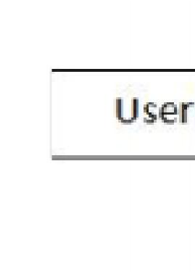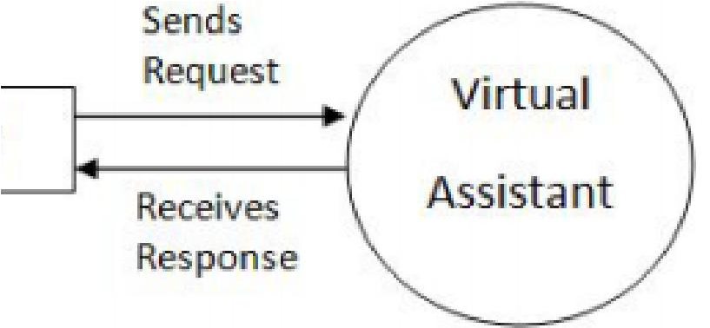

Fig1:LEVEL 0 DFD

**DFD Level 1 :-** The Level 1 DFD shows how the system is divided into sub-systems (processes), each of which deals with one or more of the data flows to or from an external agent, Level 1 Data Flow diagram shows an in depth explanation of overall process of the data flow.

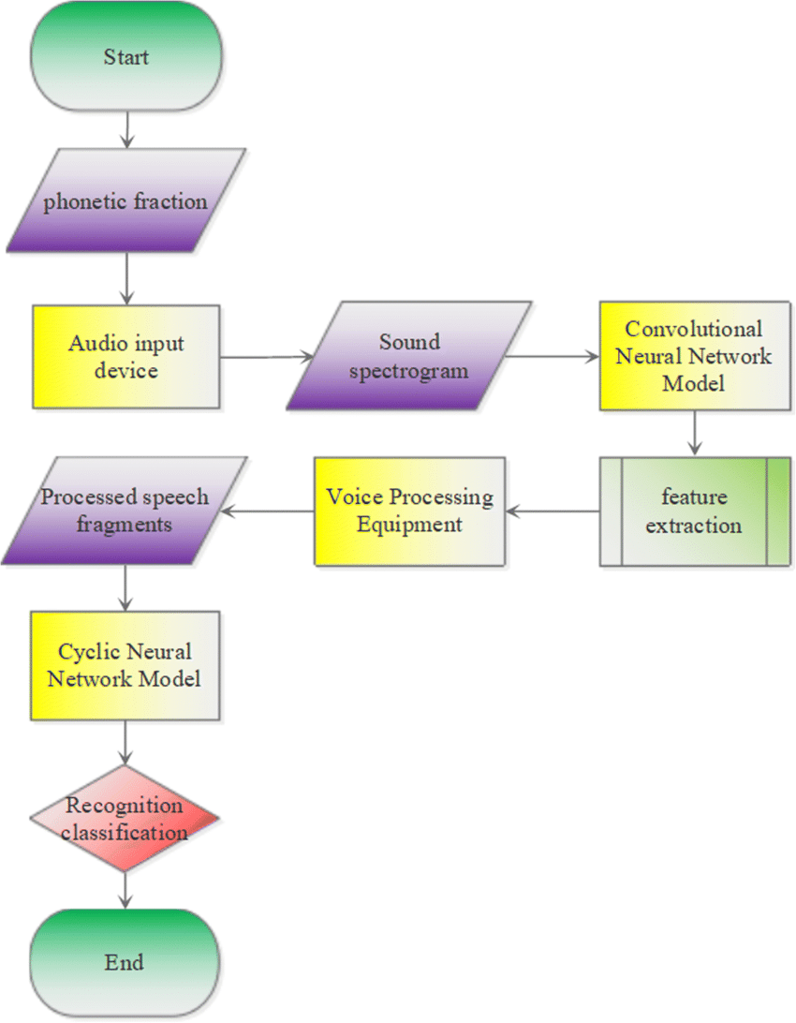

Fig2:LEVEL 1 DFD

**7**

**DFD Level 2 :-** Complete details of every function performed by Admin. Every step is explained in detail. The four components of a data flow diagram (DFD) are → External Entities/Terminators are outside of the system being modelled. Terminators represent where information comes from and where it goes. In designing a system, we have no idea about what these terminators do or how they do it. Processes modify the inputs in the process of generating the outputs. Data Stores represent a place in the process where data comes to rest. A DFD does not say anything about the relative timing of the processes, so a data store might be a place to accumulate data over a year for the annual accounting process. Data Flows shows how data moves between terminators, processes, and data stores (those that cross the system boundary are known as IO or Input Output Descriptions).

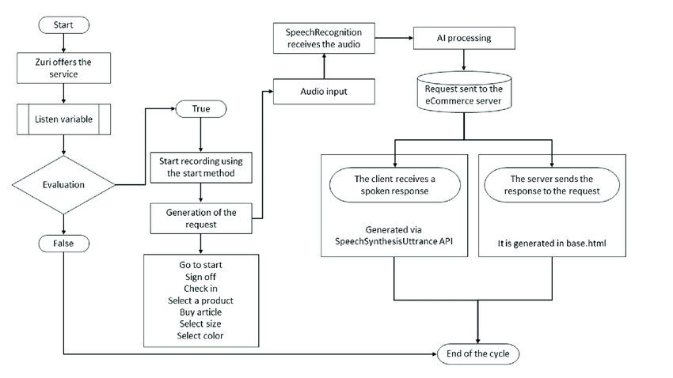

Fig 3:LEVEL 2 DFD

**8**

**ER DIAGRAM**

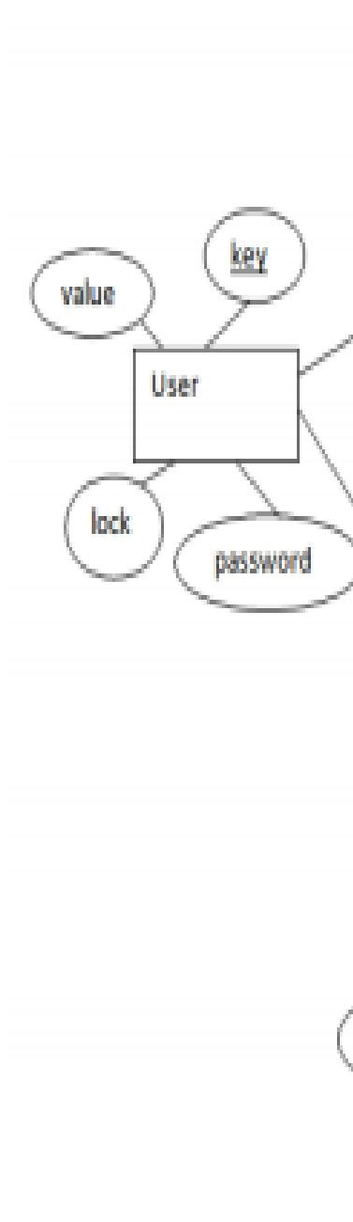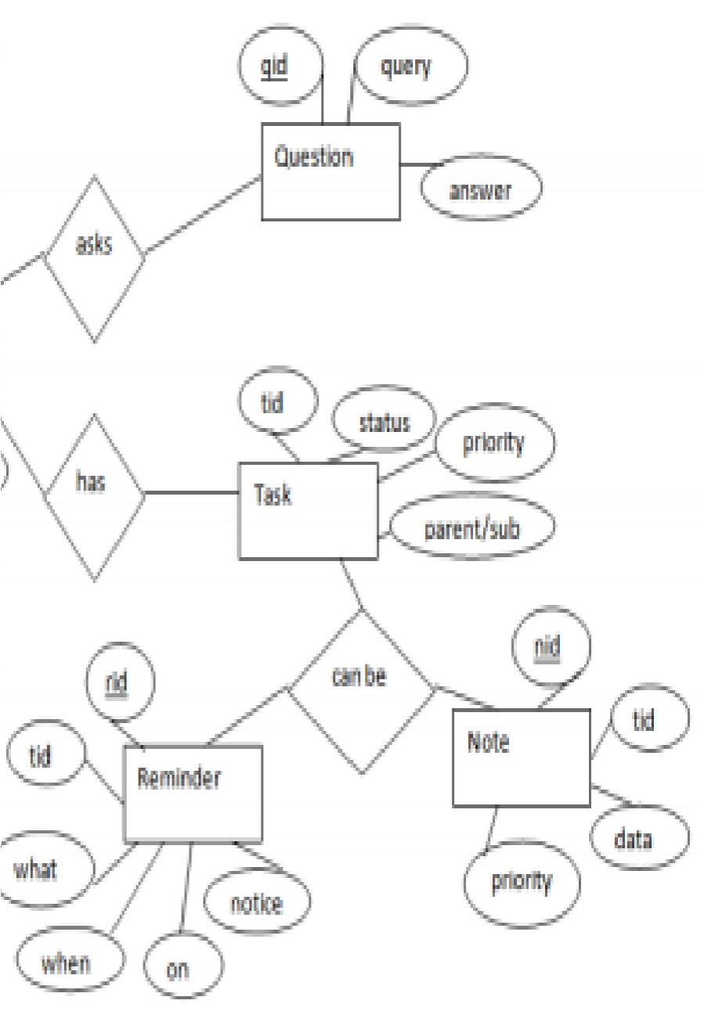

Fig4: ER DIAGRAM

**9**

**THEORY OF COMPUTATION**

At the outset we make our program capable of using system voice with the help of sapi5 and pyttsx3. pyttsx3 is a text-to-speech conversion library in Python. Unlike alternative libraries, it works offline, and is compatible with both Python 2 and 3. The Speech Application Programming Interface or SAPI is an API developed by Microsoft to allow the use of speech recognition and speech synthesis within Windows applications. Then we define the speak function to enable the program to speak the outputs.

After that we will define a function to take voice commands using the system microphone. The main function is then defined where all the capabilities of the program are defined.

• The proposed system will have the following functionality:

1. The system will keep listening for commands and the time for listening is variable which can be changed according to user requirements.
2. If the system is not able to gather information from the user input it will keep asking again to repeat till the desired number of times.
3. The system can have both male and female voices according to user requirements.
4. Features supported in the current version include playing music, texts, search on Wikipedia, or opening system installed applications, opening anything on the web browser, etc.

**10**

**SEUDO CODE**

# Import necessary libraries

# Define the say function to convert text to speech

# Optional: Implement password protection (commented out)

# Define the greetMe function to greet the user based on the current time

# Define the takecommand function to take voice input from the user

# Define the searchGoogle function to search the web using Google

# Define the searchYoutube function to search and play videos on YouTube

# Define the searchWikipedia function to search Wikipedia and summarize the result

# Define the alarm function to set an alarm using a separate script

# Define the get_temperature function to fetch the temperature of a city using the OpenWeatherMap API

# Main program

# Initialize the assistant and greet the user

# Start a loop to continuously listen for user commands

# If the user says "wake up", greet the user

# If the user says "go to sleep", end the loop

# If the user wants to change the password

# Prompt the user for a new password

# Save the new password to a file

# If the user asks for the temperature

# Prompt the user for the city name

# Fetch and say the temperature

# If the user asks for the time

# Fetch the current time and say it

**11**

# If the user wants to search on Google, YouTube, or Wikipedia

# Call the respective search function

# If the user wants to open or close an app/website

# Call the respective function from another script

# If the user wants to set an alarm

# Prompt the user for the time and set the alarm

# If the user wants to control YouTube (play, pause, mute, volume)

# Perform the respective action using keyboard shortcuts

# If the user wants to remember something

# Save the message to a file

# If the user asks what the assistant remembers

# Read and say the remembered message

# If the user wants to play music

# Randomly select and play a favorite song

# If the user wants to send a WhatsApp message

# Call the function to send a message

# If the user wants to shutdown the system

# Ask for confirmation and shutdown the system if confirmed

# If the user asks for the latest news

# Fetch and read the latest news from another script

# If the user wants to calculate something

# Call the function to perform the calculation

# If the user says "finally sleep", exit the program

# Otherwise, try to search the web using Google, YouTube, or Wikipedia

**12**

**PICTORIAL REPRESENTATION**

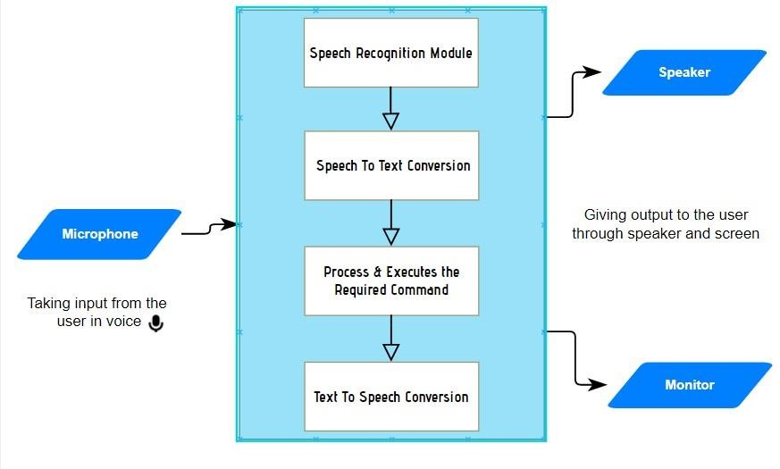

##### Fig 5: Flowchart

1. Must provide the user any information which they ask for: -

The user might need any information which will be available on the internet but searching for that information and reading that takes a lot of time but with the help of a voice assistant, we can complete that task of getting the information sooner than searching and reading it. So, this is a small proof that a voice assistant helps the user to save time

1. Telling the day's hot news in the user's location: -

In Common, watching a news channel just to know the important news in one’s location takes a lot of time and the user might even want to listen to some news which is unnecessary to them or a news of some different location before getting to know the news which they want needs a lot of patience to the user but having a voice assistant makes all that nothing, it'll give the news of the location which the user wants to now or the news which they want to know.

1. Telling some joke to chill up the moment: -

Now let's be honest, everyone would have had at least one moment in their life where they were so tensed up or had an argument with their close people. So, these moments can be chilled up at least ten percentage with some random joke which might cool us that moment or stop that fight. We even have a quote stating "Laughter is the best medicine" which is relatable to the words mentioned here in this paragraph.

**13**

1. Opening the file/folder which the user wants: -

In the busy world, everything should do quick else, our schedule will get changed and sometimes we need assistance of someone to complete that task quickly but, if we have a voice assistant, we can complete that task in right away in a hustle freeway. For example, let's say the user is doing some documentation but after a while, he needs some file for reference and he goes searching for that file which wastes a lot of time and he ends up missing the deadline but, with a voice assistant we can do the searching part in a quick way by commanding the assistant to open the folder. So, by this we can say that it is one of the important features of a voice assistant.

1. Telling the temperature/weather at the user's location: -

Let's start this with a question, why is it important for us to know the weather of the day? or why is it important for us to monitor the weather every day? The answer is pretty simple it forewarns the users asking about the weather telling that "it might rain today so carry an umbrella if you go out" or "It will be a sunny day so wear a sun glass". So, by this we can say that this is also a must have feature.

1. Searching for what the user asks:

Today in the 20th century, we people often get doubts and we need to clear that doubt as soon as possible else that one doubt will be multiplied and at the end, we'd have n doubts and to clear the doubts searching the question in the internet will give us an answer and clear our doubts and asking that to the assistant will save a lot of time. Other than clearing the doubts, we need to search a lot of questions or topics in the internet to keep up with the trend and we can do this searching just by giving command to our assistant, asking it to search a specific topic/question.

1. Internet of Things:

The final important feature which is the most important feature and that is Internet of Things which is a lot useful because, it'll save a lot of time. Let's take an example, let's say that there is a person with a walking disability and he has to turn on the fan but the switch is a bit far and he can't walk but what he can do is that, he can tell the assistant to turn on the fan and that will turn it on. This is just one example but with the help of IoT, we can do a lot of helpful stuffs like this. These are the important features of the voice assistant but other than this, we can do an ample of stuffs with the assistant.

**14**

**RESULTS AND ANALYSIS**

The project work of the voice assistant has been clearly explained in this report, how useful it is and how we can rely on a voice assistant for performing any/every task which the user needs to complete and how the assistant is developing everyday which we can hope that it'll be one of the biggest technology in the current technological world. Development of the software is almost completed form our side and it's working fine as expected which was discussed for some extra development. So, maybe some advancement might come in the near future where the assistant which we developed will be even more useful than it is now.

#### WORKING

It starts with a signal word. Users say the names of their voice assistants for the same reason.

They might say, “Hey Siri!” or simply, “Alexa!” Whatever the signal word is, it wakes up the device. It signals to the voice assistant that it should begin paying attention. After the voice assistant hears its signal word, it starts to listen. The device waits for a pause to know you’ve finished your request. The voice assistant then sends our request over to its source code. Once in the source code, our request is compared to other requests. It’s split into separate commands that our voice assistant can understand. The source code then sends these commands back to the voice assistant. Once it receives the commands, the voice assistant knows what to do next. If it understands, the voice assistant will carry out the task we asked for. For example, “Hey

NOVA! What’s the weather?” NOVA reports back to us in seconds. The more directions the devices receive, the better and faster they get at fulfilling our requests. The user gives the voice input through microphone and the assistant is triggered by the wake up word and performs the STT (Speech to Text) and converts it into a text and understands the Voice input and further performs the task said by the user repeatedly and delivers it via TTS (Text to Speech) module via AI Voice.

These are the important features of the voice assistant but other than this, we can do an plenty of things with the assistant.

List of features that can be done with the assistant:

* Playing some video which, the user wants to see.
* Telling some random fact at the start of the day with which the user can do their work in an informative way and the user will also learn something new.
* One of the features which will be there in every assistant is playing some game so that the user can spend their free time in a fun way.
* Users might forget to turn off the system which might contain some useful data but with a voice assistant, we can do that even after leaving the place where the system is just by commanding the assistant to turn the system off.

**15**

**CONCLUSION**

As stated before, “voice assistant is one of the biggest problem solver” and you can see that in the proposals with the examples that it is in fact one of the biggest problem solver of the current world. We can see that voice assistant is one of the major evolving artificial intelligence in the current world once again on seeing the proposal examples because at the past, the best feature which a voice assistant had was telling the date and searching the web and giving the results but now look at the functions that it can do so with this, we can say that it is a evolving software in the current world. The main idea is to develop the assistant even more advanced than it is now and make it the best ai in the world which will save an ample of time for its users. I would like to conclude with the statement that we will try our best and give one of the best voice assistants which we are able to.

**16**

### FUTURE SCOPE

We are entering the era of implementing voice-activated technologies to remain relevant and competitive. Voice-activation technology is vital not only for businesses to stay relevant with their target customers, but also for internal operations. Technology may be utilized to automate human operations, saving time for everyone. Routine operations, such as sending basic emails or scheduling appointments, can be completed more quickly, with less effort, and without the use of a computer, just by employing a simple voice command. People can multitask as a result, enhancing their productivity. Furthermore, relieving employees from hours of tedious administrative tasks allows them to devote more time to strategy meetings, brainstorming sessions, and other jobs that need creativity and human interaction.

1. Sending Emails with a voice assistant:

Emails, as we all know, are very crucial for communication because they can be used for any professional contact, and the finest service for sending and receiving emails is, as we all know, GMAIL. Gmail is a Google-created free email service. Gmail can be accessed over the web or using third-party apps that use the POP or IMAP protocols to synchronize email content.

To integrate Gmail with Voice Assistant we have to utilize Gmail API. The Gmail API allows you to access and control threads, messages, and labels in your Gmail mailbox.

1. Scheduling appointments using a voice assistant:

The demands on our time increase as our company grows. A growing number of people want to meet with us. We have a growing number of people who rely on us. We must check in on certain projects or set aside time to chat with possible business leads. There won't be enough hours in the day if we keep doing things the old way.

We need to get a better handle on our full-time schedule and devise a strategy for arranging appointments that doesn't interfere with our most critical job. By working with a virtual scheduler or, in other words, a virtual assistant, we let someone else worry about the organization and prioritize our schedule while we focus on the work.

1. Improved Interface of a voice assistant (VUI):

Voice user interfaces (VUIs) allow users to interact with a system by speaking commands. VUIs include virtual assistants like Amazon's Alexa and Apple's Siri. The real advantage of a VUI is that it allows users to interact with a product without using their hands or their eyes while focusing on anything else.

**17**

### REFERENCES

1. K. Noda, H. Arie, Y. Suga, T. Ogata, Multimodal integration learning of robot behavior using deep neural networks, Elsevier: Robotics and Autonomous Systems, 2014.

1. Artificial intelligence (AI), sometimes called machine intelligence. [https://en.wikipedia.org/wiki/Artificial_intelligence.](https://en.wikipedia.org/wiki/Artificial_intelligence)

1. Deepak Shende, RiaUmahiya, Monika Raghorte, AishwaryaBhisikar, AnupBhange, “AI

Based Voice Assistant Using Python”, Journal of Emerging Technologies and Innovative Research (JETIR), February 2019, Volume 6, Issue 2.

1. J. B. Allen, “From lord rayleigh to shannon: How do humans decode speech,” in International Conference on Acoustics, Speech and Signal Processing, 2002.

1. John Levis and Ruslan Suvorov, “Automatic Speech Recognition”.

1. B.H. Juang and Lawrence R. Rabiner, “Automatic Speech Recognition - A Brief History of the Technology Development”.

1. AbhayDekate, ChaitanyaKulkarni, RohanKilledar, “Study of Voice Controlled Personal

Assistant Device”, International Journal of Computer

Trends and Technology (IJCTT) – Volume 42 Number 1 – December 2016.

**18**